CSC 330 – Artificial Intelligence

**Video #3 – Homework Assignment**

Using direct utility estimation, show the updated utility values for the states below, assuming the agent follows the path shown.

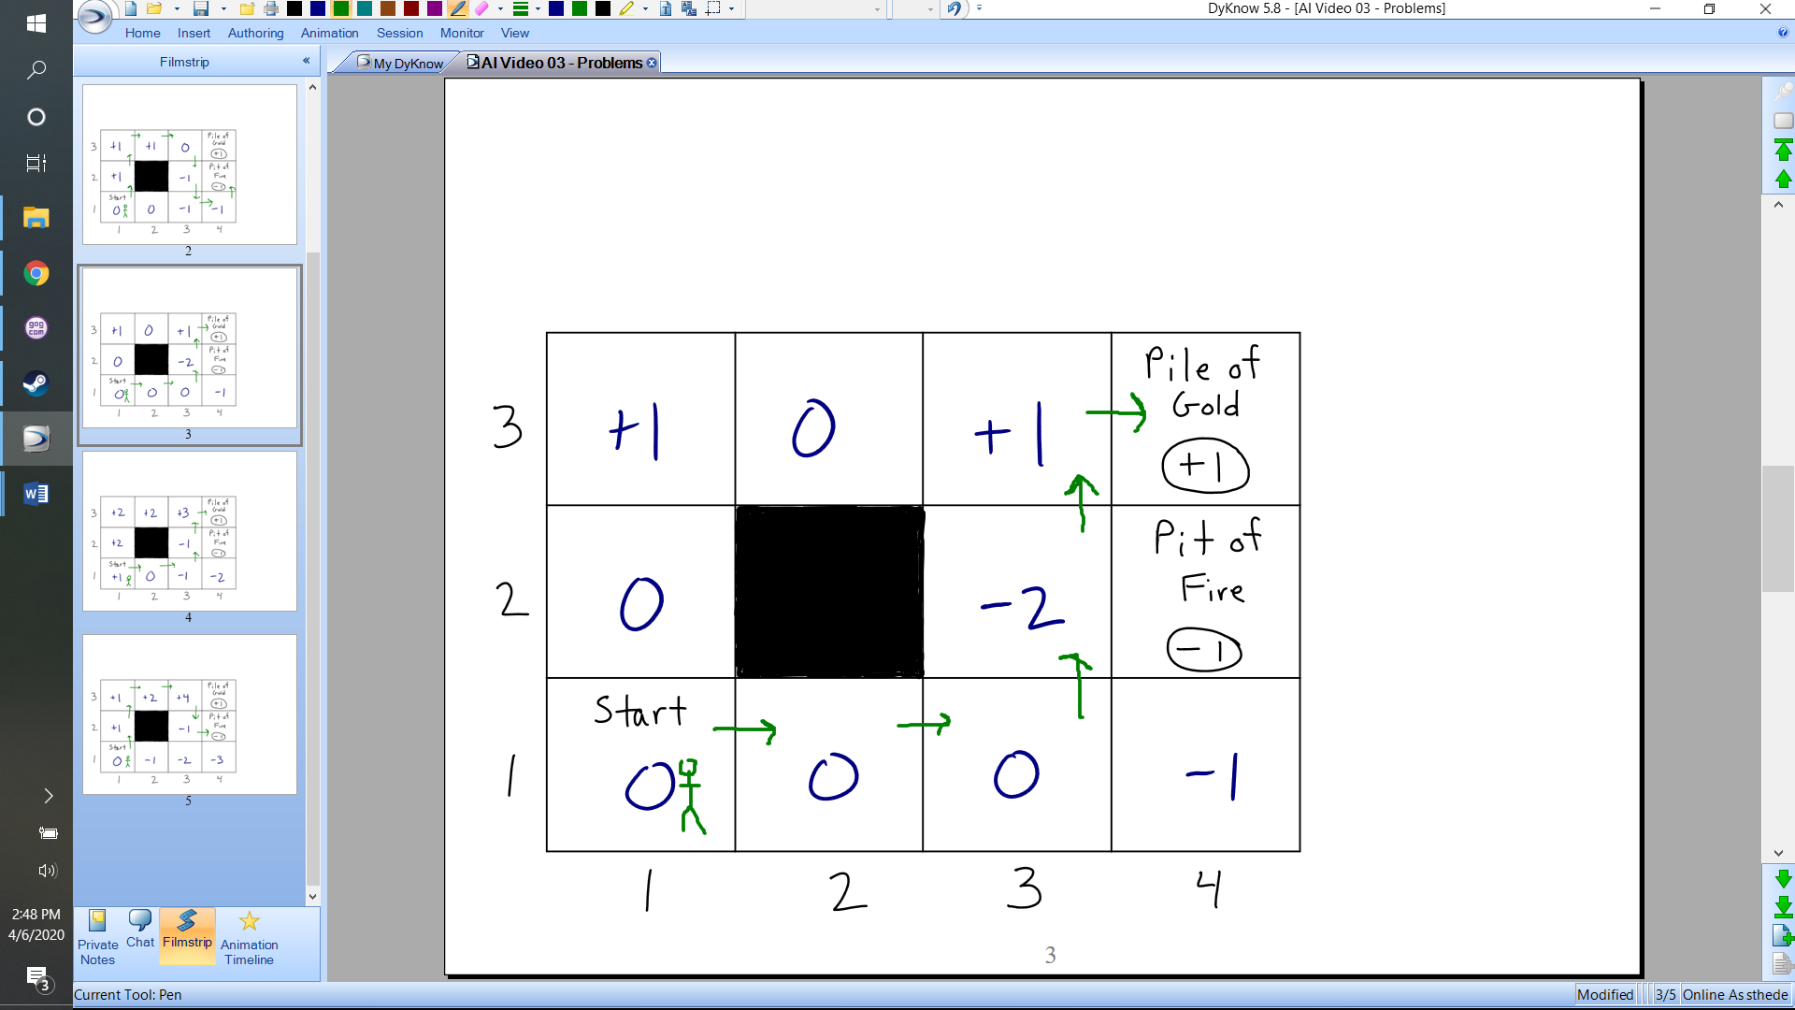



Using temporal difference learning, show the updated utility values for the states below, assuming the agent follows the path shown. Assume that  is equal to 1, and  is equal to 0.5.



